**AWS Solution Architect Course: Project 3 Scenario – Submission by Aruna Annavajjula**

**Instructor- Aakash**

Your company wants to distribute their content in the form of a website to their global offices. However, due to some legal restrictions, you cannot distribute the content in France and Australia. You need to find a way to prevent these offices from accessing the data. The content does not change very often; however, some of the files are very large, and you have to find a solution to minimize end user latency. The last requirement is that the audit department wants to track whoever is accessing the website.

**Goals of the project:**

**Set up a static website using Amazon S3**.

**Create a bucket and enable static website hosting. Enable logging.**

**Buckets-project-media-lms and arunas3bucket**

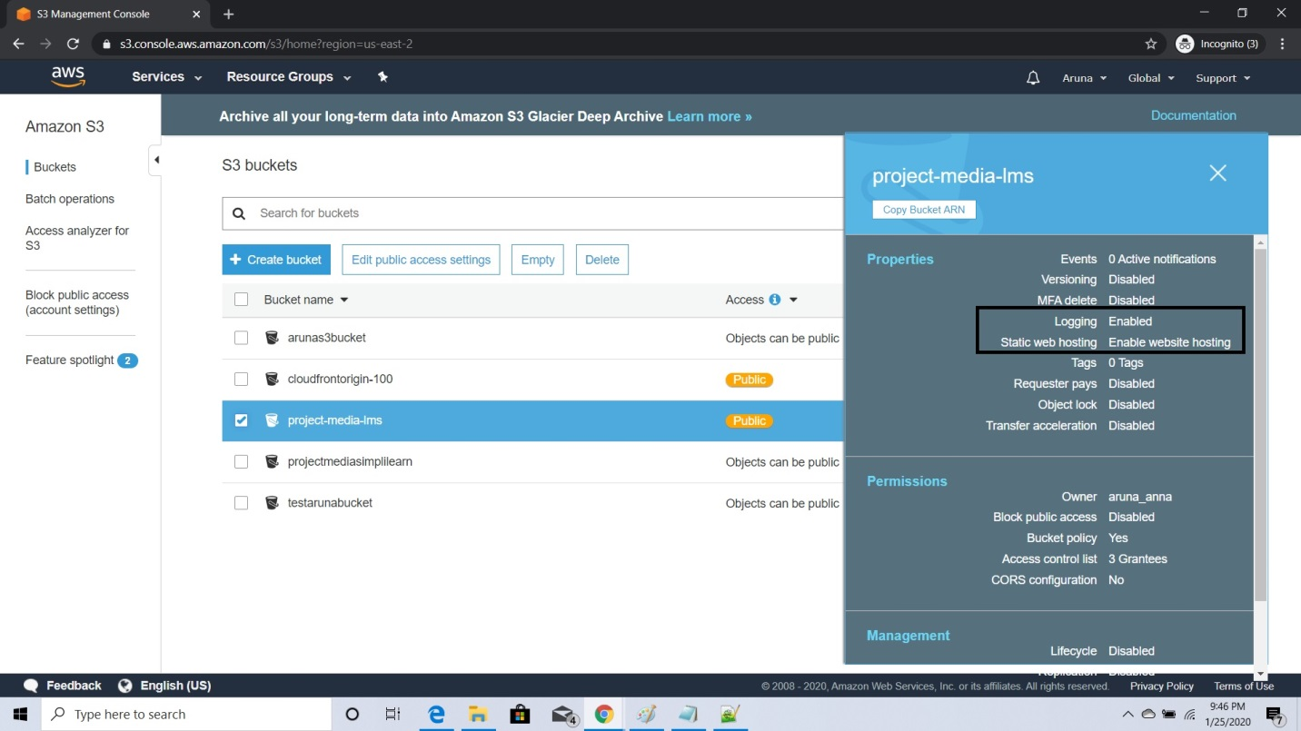

**Properties for project-media-lms bucket**

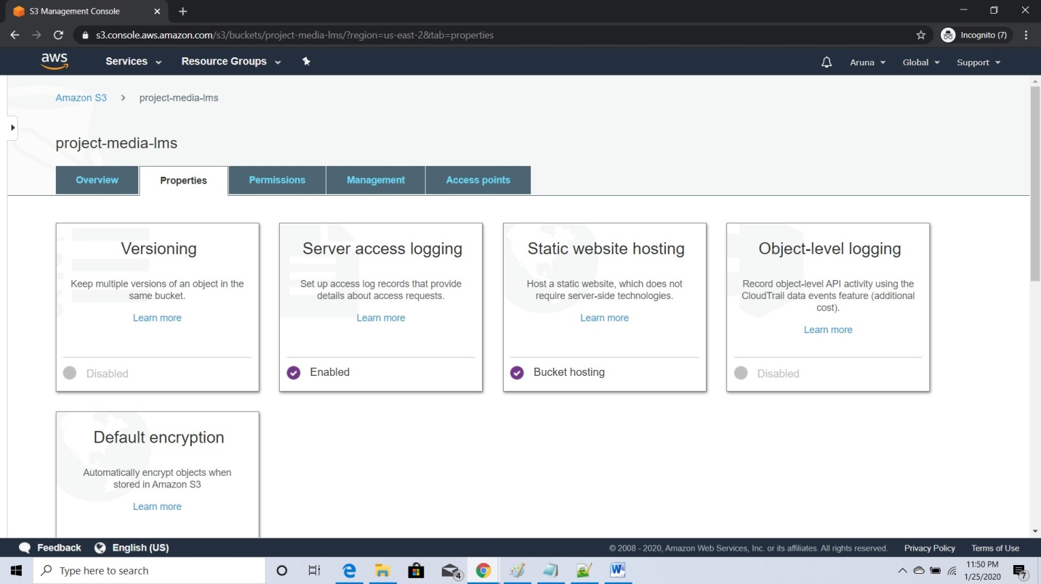

**Public Access Policy:**

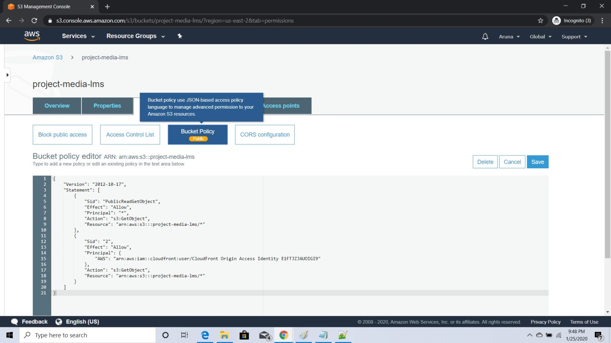

**Project-media-lms static web hosting page after made it public:**

<https://project-media-lms.s3.us-east-2.amazonaws.com/index.html>

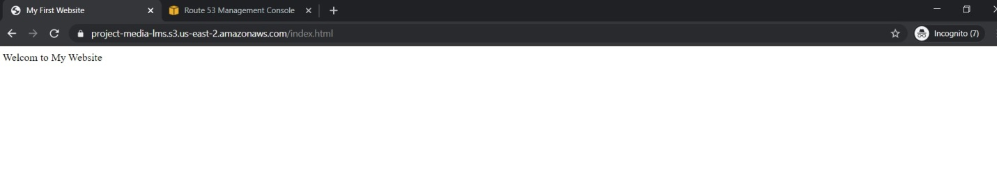

arunas3bucket- static web hosting page after made it public

<https://arunas3bucket.s3.amazonaws.com/index.html>

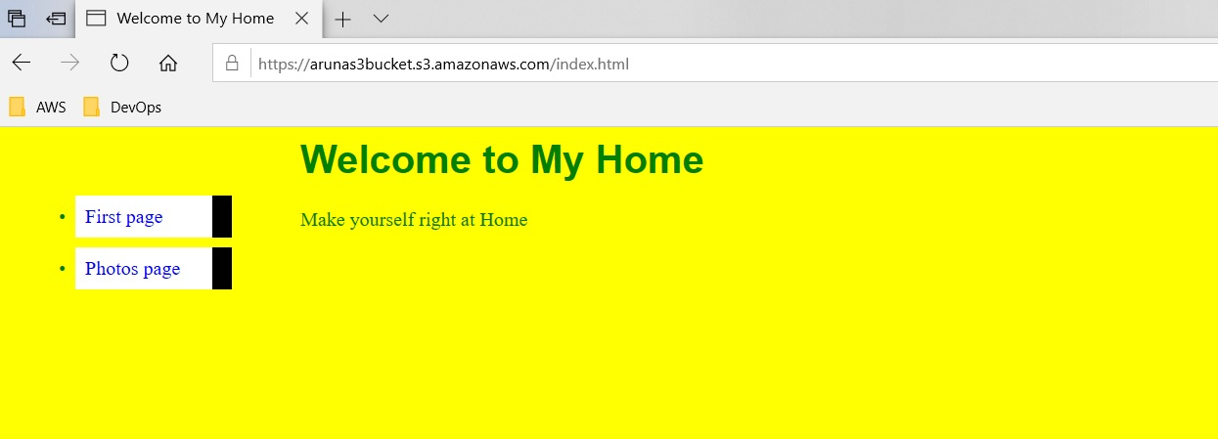

Click on Photos page:

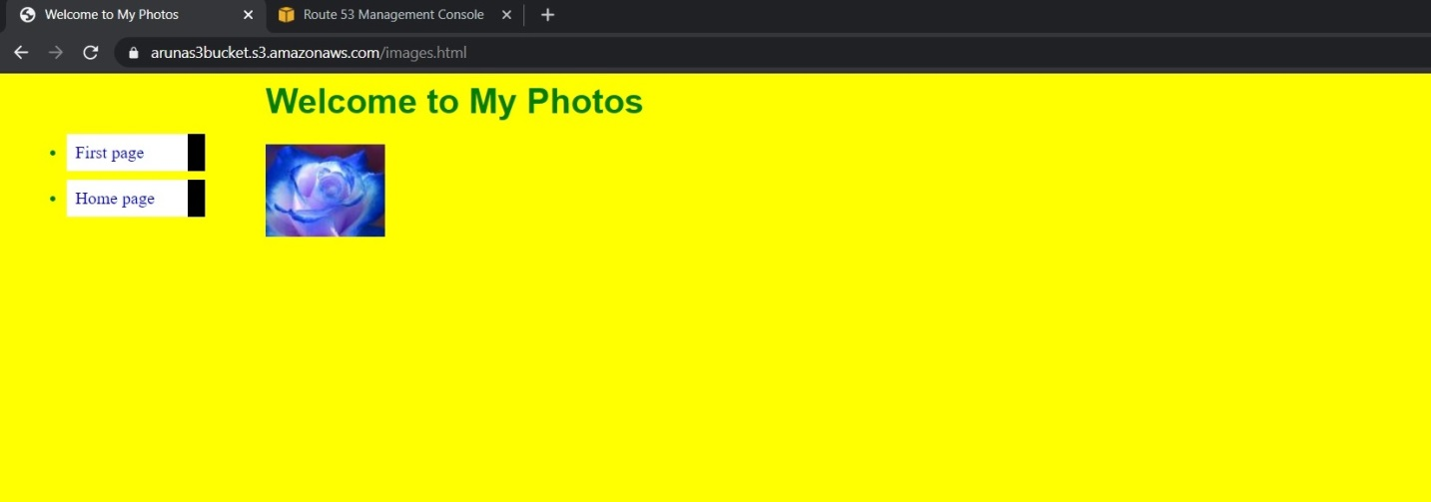

**Project-media-lms - logs from S3**

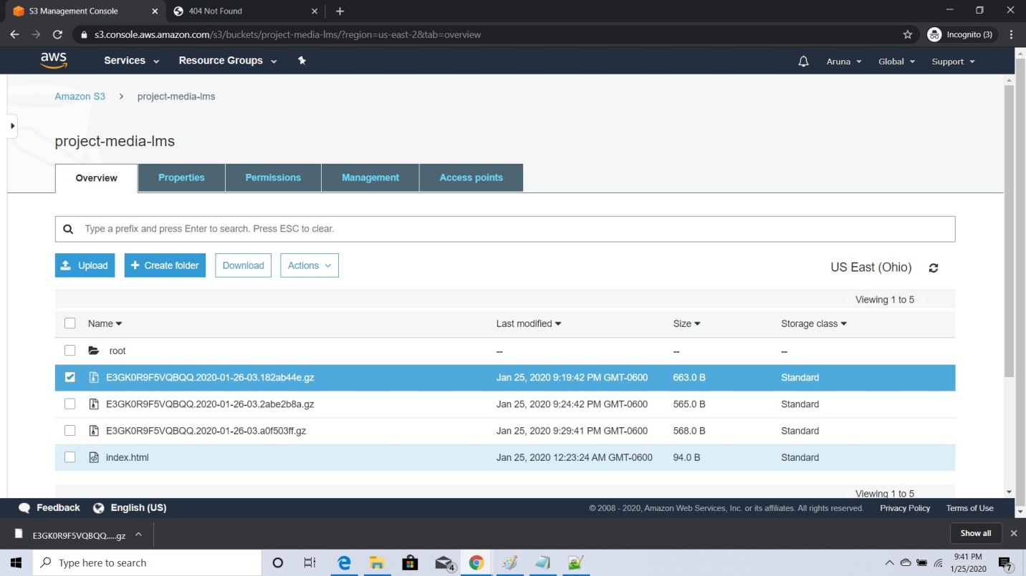

**arunas3bucket- logs from S3**

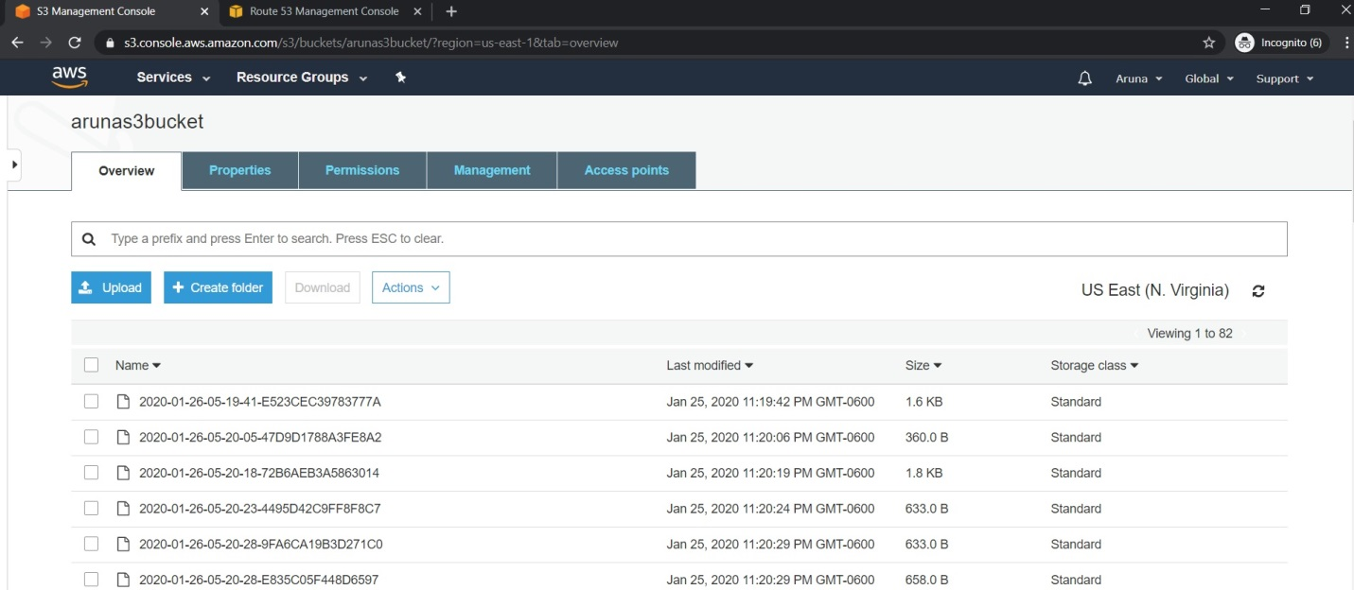

**Set up a CloudFront distribution for the static website with Access Logs enabled.**

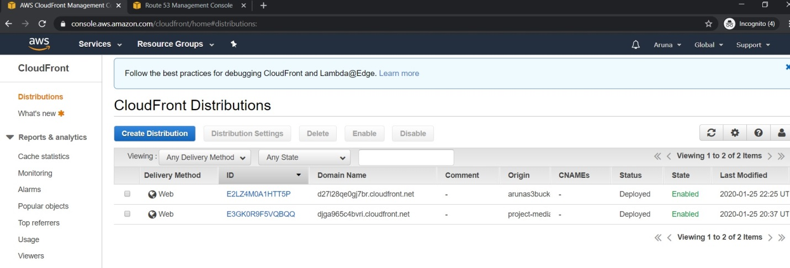

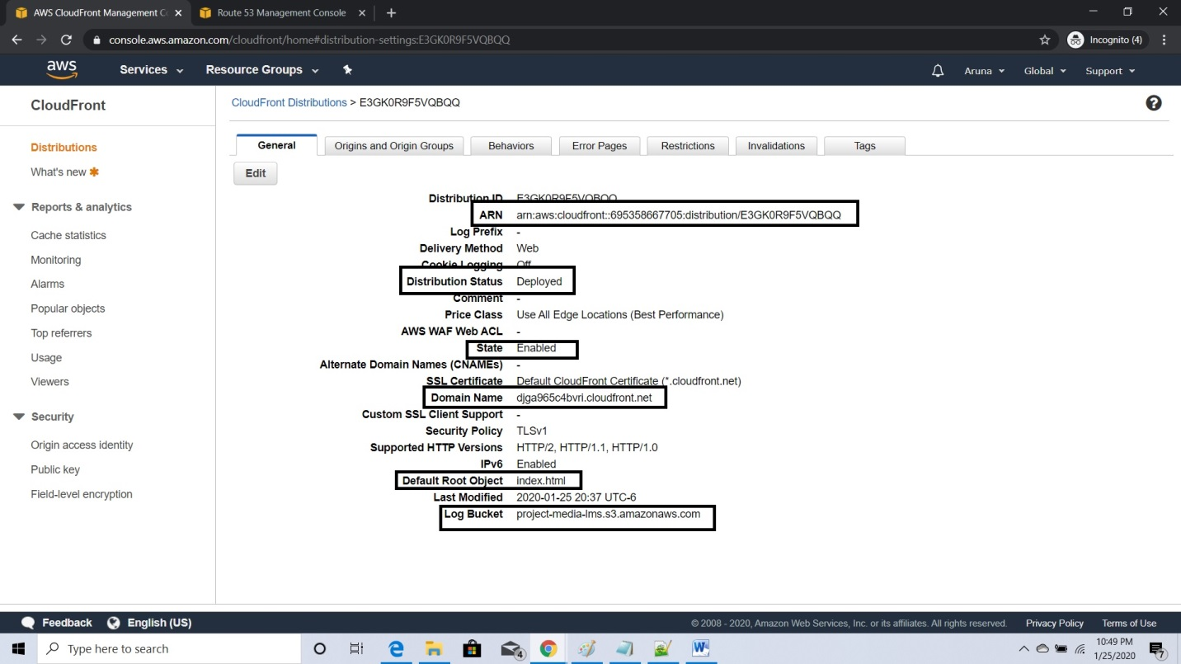

**Set up Geo Restrictions to prevent users in France and Australia from accessing the data.**

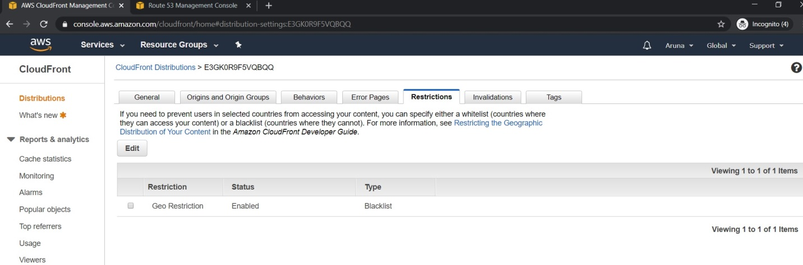

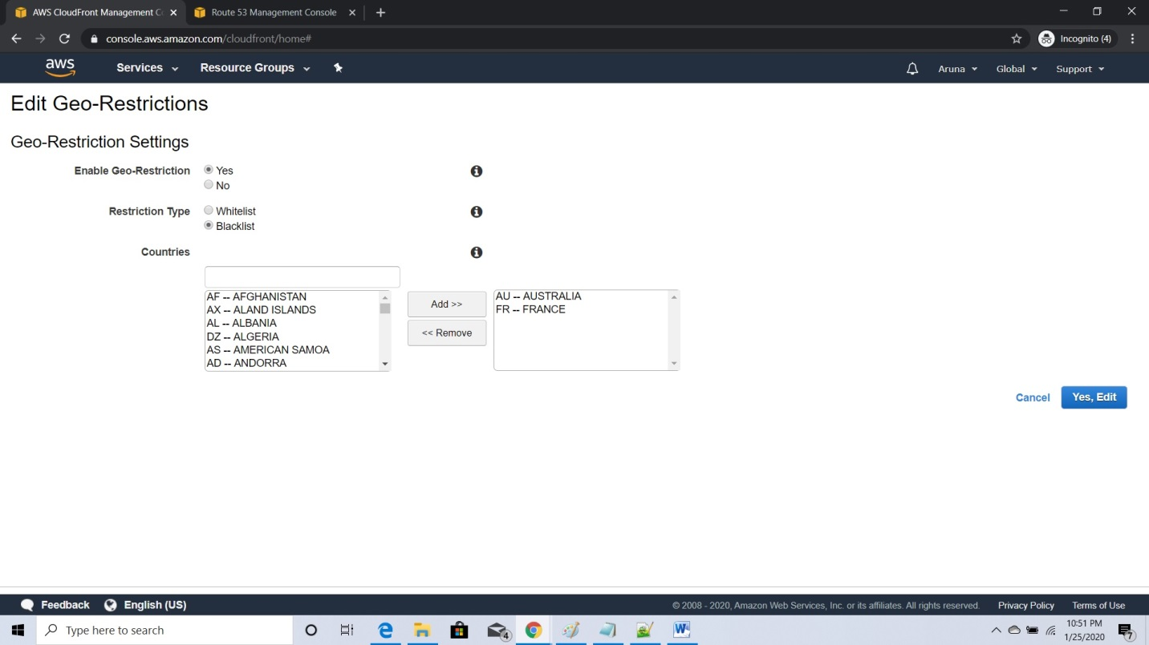

Domain name web url: djga965c4bvri.cloudfront.net

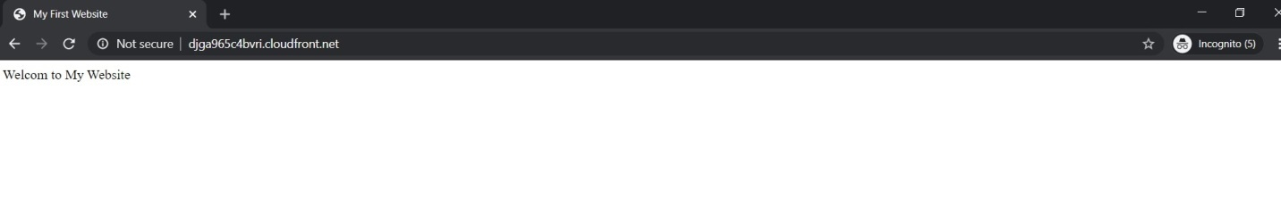

arunas3bucket-CloudFront Distribution:

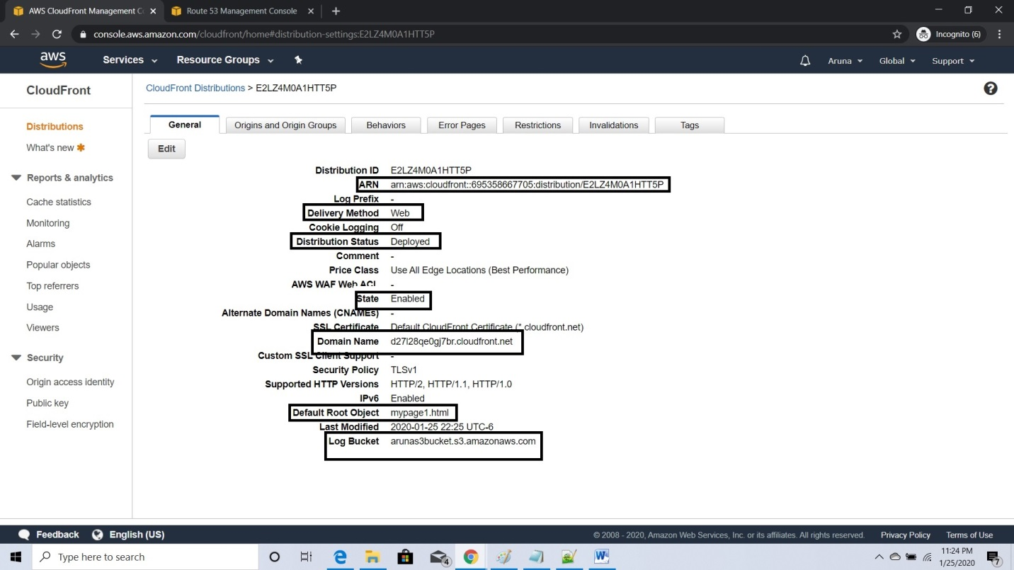

No Geo restriction for aruna s3bucket

Domain name web url: d27l28qe0gj7br.cloudfront.net

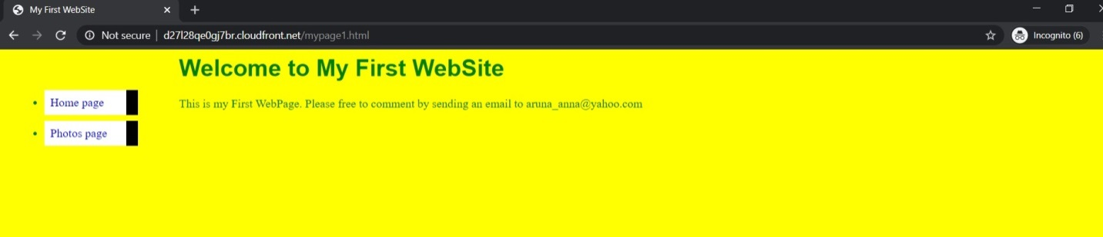

**Verify that logging is working.**

